

COMSATS University Islamabad

**Abbottabad Campus**

*Project Proposal*  
UNIVERSITY ADMISSION SYSTEM

***CSC392*** *OBJECT ORIENTED SOFTWARE ENGINEERING*

*By*

**SYED SHAH HUSSAIN FA21-BSE-172**

**MAHAD WAJID FA21-BSE-057**

**ABDUL AZIZ FA21-BSE-058**

**SOMAN AHMED FA21-BSE-150**

**DANYAL NAWAZ FA21-BSE-083**

**HAMZA BADAR FA21-BSE-055**

**AJWAH SARDAR FA21-BSE-072**

*Bachelor of Science in* ***SOFTWARE ENGINEERING***

***(2021-2025)***

Supervisor: ***MUKHTIAR ZAMIN***

Contents

**CHAPTER 1:** 3

INTRODUCTION: 3

VISION AND SCOPE: 3

BUSINESS CASES: 4

SPECIAL REQUIREMENTS / EXPECTED QUALITY MEASURES: 4

RISKS WITH MEGITATION PLAN: 4

**CHAPTER 2:** 5

USE CASES DISTRIBUTION; 5

USE CASE DIAGRAM: 6

BRIEF LEVEL USE CASES: 7

SYED SHAH HUSSAIN (FA21-BSE-172): 7

MAHAD WAJID (FA21-BSE-057) 8

FULLY DRESSED USE CASES WITH UI PROTOPTYPE: 9

SYED SHAH HUSSAIN BADSHAH (FA21-BSE-172) 9

MAHAD WAJID (FA21-BSE-057) 11

# **CHAPTER 1:**

## INTRODUCTION:

As the number of students appearing for the counseling are increasing rapidly every year, it requires much effort and time to handle the admission system with man power and paper system. So we are in need of a better system to make the process easier and serves better which could be done by Computerized Student Admission System that facilitates the work of the universities and at the same time it must reduce the work load of the organization with expected quality. Quality in the sense, the system tries to avoid the mistakes that are usually happen during the Admission Process. The University Admission System has been developed in order to automate the complete admission system starting from the notification to admission process.

The system enables online admissions saving the time of the geographically scattered students. It enables reducing time in activities, centralized data handling and paperless admission with reduced manpower. It improves the operational efficiency and reduces the cost. It also provides consist view of data and integration with other institutions for verification of marks and details.

## VISION AND SCOPE:

**Vision:**

The vision of a university admission system is to provide an accessible, fair, and efficient process for selecting and admitting the most qualified candidates to the academic programs offered by the university. The system should ensure that every applicant is given equal consideration and opportunities for success, regardless of their background, ethnicity, gender, or financial status.

**Scope:**

The scope of a university admission system includes the following:

**Application process:** This involves developing and implementing an online or paper-based application process that includes all necessary fields and information required to evaluate the applicant's qualifications.

**Evaluation process:** This includes the development of evaluation criteria that are aligned with the academic program's requirements, and the review of applications by the admissions committee or evaluators. The evaluation process may also include interviews, essays, and letters of recommendation.

**Admission decision**: This involves making the final admission decision based on the evaluation results and the requirements of the academic program.

**Communication and documentation:** This includes notifying applicants of the admission decision and providing any additional documentation required for enrollment, such as transcripts, financial aid forms, or health records.

**Continuous improvement:** The university admission system should continuously monitor and evaluate its processes and outcomes, and make improvements as necessary to ensure that it remains effective and aligned with the university's mission and goals.

## BUSINESS CASES:

## SPECIAL REQUIREMENTS / EXPECTED QUALITY MEASURES:

## RISKS WITH MEGITATION PLAN:

# **CHAPTER 2:**

## USE CASES DISTRIBUTION;

|  |  |  |
| --- | --- | --- |
| Name | Reg No | Assign Use cases |
| Hamza badar | Fa21-bse-055 | 1.View admin,  2.Published Merit list  3. Check Merit List |
| Mahad Wajid | Fa21-bse-057 | 1.Enter Personal info  2.Announcement  3.Scheduling test |
| Abdul Aziz | Fa21-bse-058 | 1.Take Test  2. Print Challan  3. Make Test Payment  4.Make Admission payment |
| Soman Ahmed | Fa21-bse-150 | 1.Logout,  2.Academic info  3.verify document |
| Danyal Nawaz | Fa21-bse-083 | 1.Login  2.Apply for test  3. Apply For Admission |
| Shah Hussain | Fa21-bse-172 | 1.Notify  2.Admission Confirmation |
| Ajwa Sardar | Fa21-bse-072 | 1.Registration  2.Arrange Test  3.Admission Criteria |

## USE CASE DIAGRAM:

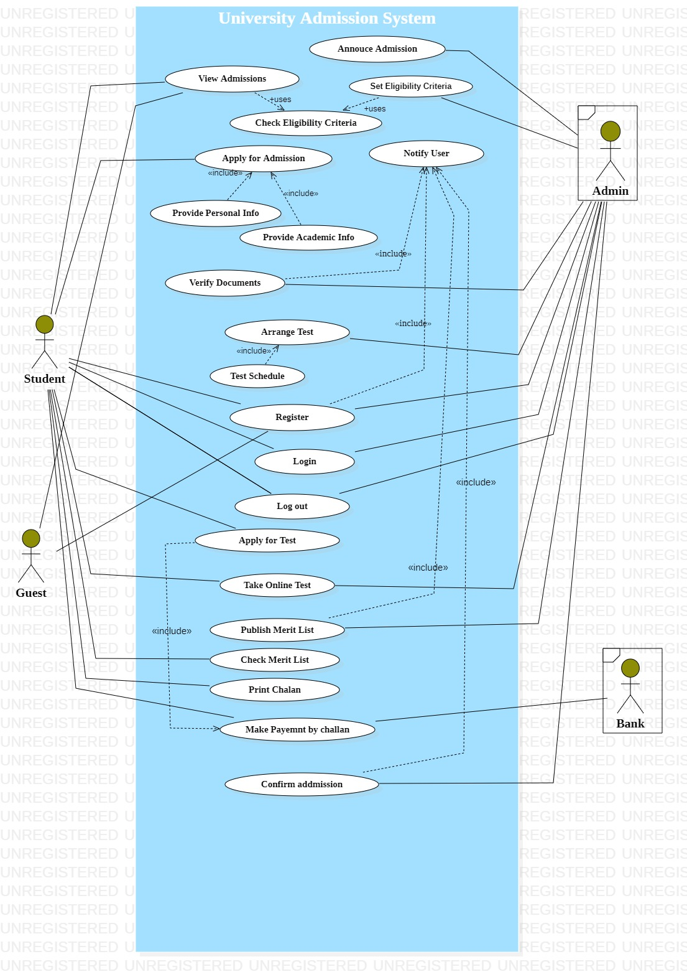

## BRIEF LEVEL USE CASES:

### SYED SHAH HUSSAIN (FA21-BSE-172):

#### Use Case: NOTIFY (ADVERTISEMENT)

1. **Admission Offer Notifications:** The university admission system can notify applicants of their admission offer, which will contain information about the program they have been accepted into, the start date, and any other important information.
2. **Rejection Notifications:** If an applicant's admission is rejected, the university admission system can notify them with an explanation of why they were not accepted and any other helpful information about next steps.
3. **Waitlist Notifications**: If an applicant is placed on a waitlist, the university admission system can notify them of their status and provide them with any additional information they may need to know.
4. **Deadline Reminders**: The university admission system can also send reminders to applicants about upcoming deadlines, such as the deadline to accept an offer of admission or submit any required documents.
5. **Scholarship Notifications**: If a scholarship is awarded, the university admission system can notify the applicant of the award amount and any additional information they may need to know.
6. **Orientation Information:** The university admission system can also notify admitted students of upcoming orientation dates and any other relevant information that will help them prepare for their first day of classes.

#### Use Case: CONFIRM ADMISSION

1. **Acceptance of admission offer:** The system could allow newly admitted students to confirm their acceptance of the admission offer through an online portal. This would help the university to accurately estimate the incoming class size and plan for enrollment.
2. **Confirmation of enrollment status**: The system could allow students to check their enrollment status and confirm their enrollment in the courses they plan to take.
3. **Confirmation of financial aid and scholarship status**: The system could allow students to confirm their financial aid and scholarship status and accept or decline any offers they have received.
4. **Confirmation of attendance at orientation events:** The system could allow students to confirm their attendance at orientation events, which are typically held prior to the start of the semester to help new students acclimate to campus life.
5. **Acknowledgment of university policies:** The system could require students to confirm their acknowledgment of university policies, such as academic integrity and conduct standards, before they are fully enrolled.

### MAHAD WAJID (FA21-BSE-057)

#### Use Case: Enter Personal Info

1. **Application processing**: Personal information is required to process and evaluate applications for admission. This includes basic information such as name, address, contact details, and academic records.
2. **Communication:** Personal information such as email address and phone number is needed to communicate with student about their application status, interviews, and other related matters.
3. **Financial aid:** Personal information is used to determine eligibility for financial aid, scholarships, and other forms of financial assistance. This includes information about income, assets, and family background.
4. **Accommodation**: Personal information is used to determine accommodation options for students, including preferences for living arrangements and any special needs.
5. **Health and safety:** Personal information is required for health and safety purposes, such as medical history, emergency contacts, and insurance information.
6. **Diversity and inclusion**: Personal information is used to promote diversity and inclusion in the university community, such as gathering information about an applicant's race, ethnicity, or socioeconomic background.

#### Use Case: Scheduling Test

1. **Standardized testing:** Many universities require applicants to take standardized tests such as the SAT, ACT, GRE, or GMAT. Test schedules are used to inform applicants of upcoming test dates, registration deadlines, and other important information related to the testing process.
2. **Subject-specific testing**: Some universities may require students to take subject-specific tests in addition to standardized tests. Test schedules are used to inform applicants of the specific tests required, the dates and locations of the tests, and any registration deadlines.
3. **Language proficiency testing:** For international students, universities may require proof of English proficiency through tests such as TOEFL or IELTS. Test schedules are used to inform students of the testing process, including available test dates, registration deadlines, and test fees.
4. **Accommodation for test takers:** Test schedules are used to ensure that appropriate accommodations are provided for test takers with disabilities or other special needs, such as extended testing time or special testing conditions.
5. **Test score submission deadlines:** Universities may have specific deadlines for receiving test scores from applicants. Test schedules are used to inform students of these deadlines, allowing them to plan accordingly and ensure that their scores are submitted on time.
6. **Alternate testing arrangements**: In some cases, universities may offer alternate testing arrangements for students who are unable to take the test on the scheduled date, such as makeup exams or remote testing options. Test schedules are used to inform students of these options and the associated deadlines and requirements.

#### Use Case: Announcement

1. **Application deadlines:** Universities may use announcements to inform prospective students of application deadlines, including early decision or early action deadlines, regular decision deadlines, and any applicable extension deadlines.
2. **Admission decision notifications:** Universities may use announcements to inform applicants of admission decisions, including acceptance, rejection, or waitlist status. These notifications may include instructions on next steps for admitted students, such as submitting a deposit or registering for classes.
3. **Scholarship and financial aid announcements**: Universities may use announcements to inform students of scholarship and financial aid opportunities, including deadlines for submitting applications and instructions for how to apply.
4. **Open house and campus visit announcements:** Universities may use announcements to promote campus visits and open house events, providing information on dates, times, and registration details.
5. **Program updates and changes:** Universities may use announcements to inform students of changes or updates to academic programs or requirements, as well as new program offerings or changes to admission requirements.
6. **Important dates and deadlines**: Universities may use announcements to highlight important dates and deadlines related to the admission process, such as when transcripts or test scores are due, or when students can expect to receive their admission decision.

## FULLY DRESSED USE CASES WITH UI PROTOPTYPE:

### SYED SHAH HUSSAIN BADSHAH (FA21-BSE-172)

#### Use Case: Notify (ADVERTISEMENT)

|  |  |
| --- | --- |
| Use Case Name | Notify (Advertisement) |
| Scope | This use case covers the process of notifying potential applicants of upcoming admissions for the university. |
| Primary Actors | University Administrators |
| Stakeholders | University Administrators, Prospective Applicants |
| Pre-Conditions | The university has upcoming admissions, and the university administrators have prepared the admission advertisement. |
| Main Success Scenario | 1. The university administrators access the admission system and select the Notify feature.  2. The administrators create the admission advertisement, including the required information, such as application deadlines, required documents, and admission criteria.  3. The administrators select the target audience for the notification based on various criteria, such as age, academic level, location, and interests.  4. The admission system generates the notification and sends it to the target audience via email or other communication channels.  5. Prospective applicants receive the notification and follow the instructions to apply for admission. |
| Alternative Scenarios | - If there are technical issues with the admission system, the administrators will contact the IT department to resolve the issue.  - If the notification fails to reach the target audience, the administrators will investigate the issue and take appropriate actions to resolve it. |
| Success Guarantee | The notification process will be successful, and the target audience will receive the admission advertisement. |
| Expectations | The university administrators expect to reach a wide audience of potential applicants and to receive a high number of applications as a result of the admission advertisement. |
| Frequency of Occurrence | This use case occurs periodically, depending on the admission cycles of the university. |
| Technology and Data Variation List | - Operating System: Windows, Mac OS, Linux  - Web Browser: Chrome, Firefox, Safari, Edge  - Communication Channels: Email, Social Media, SMS |
| Prototype | A prototype of the notify feature will be developed to test the use case. |
| Miscellaneous | None. |
| Use Case Section | Admission |
| Special Requirements | The admission advertisement should include all necessary information for prospective applicants to apply for admission, including any required documents and deadlines. The notification should also be personalized and relevant to the target audience to increase the chances of attracting qualified applicants. |

#### Use Case: Confirm Admission

|  |  |
| --- | --- |
| Use Case Name | Confirm Admission |
| Scope | This use case covers the process of confirming admission for accepted applicants in the university admission system. |
| Primary Actors | Accepted Applicants |
| Stakeholders | Accepted Applicants, University Administrators |
| Pre-Conditions | The applicant must have been accepted into the university through the admission system. |
| Main Success Scenario | 1. The accepted applicant logs into the admission system using their credentials.  2. The applicant views the status of their admission and any pending tasks required for enrollment.  3. The applicant confirms their intention to enroll in the university.  4. The admission system generates an admission confirmation letter for the applicant.  5. The applicant receives the admission confirmation letter and follows any instructions provided. |
| Alternative Scenarios | - If the applicant is unable to log in, they will contact the IT department for assistance.  - If there are any technical issues with the admission system, the applicant will contact the IT department to resolve the issue. |
| Success Guarantee | The admission confirmation process will be successful, and the applicant will receive confirmation of their admission to the university. |
| Expectations | The applicant expects to receive confirmation of their admission and to have clear instructions for the enrollment process. |
| Frequency of Occurrence | This use case occurs frequently during the enrollment period. |
| Technology and Data Variation List | - Operating System: Windows, Mac OS, Linux  - Web Browser: Chrome, Firefox, Safari, Edge  - Data Format: PDF, Email, Text Message |
| Prototype | A prototype of the admission confirmation process will be developed to test the use case. |
| Miscellaneous | None. |
| Use Case Section | Admission |
| Special Requirements | The admission confirmation letter should include all necessary information for the applicant to complete the enrollment process, including any required documents and deadlines. |

### MAHAD WAJID (FA21-BSE-057)

#### Use Case: Enter Personal Info

|  |  |
| --- | --- |
| Use case name | Personal Info |
| Scope | The Personal Info use case describes the functionality of the university admission system for gathering and managing the personal information of prospective students. |
| Main Success Scenario | * The student navigates to the Project University Admission system and clicks on the "Enter Personal Info" button. * The system presents a form to the user, asking for personal information such as name, address, phone number, email address, and any other relevant details. * The student fills out the form with accurate and complete information and submits it. * The system verifies that all required fields have been filled out correctly and prompts the user to confirm their submission. * The student confirms the submission and the system displays a confirmation message indicating that their personal information has been successfully recorded. * The system then redirects the user to the next step in the admission process, such as submitting transcripts or completing an application essay. |
| Pre-Condition | The prospective student must have applied for admission to the university. |
| Primary Actors | Student |
| Level | Level 1: Basic Level: The student enters their personal information into the university admission system.  Level 2: Intermediate Level: The system validates the entered data and checks for any errors or missing information.  Level 3: Advanced Level: The system saves the information in the database and displays a confirmation message to the student. |
| Stake Holders | Prospective students: The primary stakeholders who benefit from the Personal Info use case by having their personal information accurately recorded and stored in the university admission system.  University administrators: The secondary stakeholders who benefit from the Personal Info use case by having access to accurate and up-to-date personal information for each prospective student. |
| Success Guarantee | The personal information of the prospective student is accurately recorded and stored in the university admission system. |
| Exceptions | The university admission system should be user-friendly and easy to navigate.  The system should validate the entered data and check for any errors or missing information.  The personal information of the student should be securely stored in the database.  The system should provide clear and concise feedback to the student on the status of their personal information. |
| Special Requirements | The university admission system must comply with all applicable data privacy laws and regulations. |
| Technology and data variation list | Technology: The university admission system is a web-based application that requires a modern web browser and an internet connection.  Data Variation: The personal information entered by the student may vary in format and content, depending on the student's background and cultural norms. |
| Frequency of occurrences | This use case occurs for each new prospective student who applies for admission to the university. |
| Miscellaneous | The Personal Info use case is one of several use cases in the university admission system, including Application Submission, Transcript Submission, Test Scores Submission, and Admissions Decision. |
| Prototyping | A prototype of the university admission system with the Personal Info use case can be developed and tested with a small group of prospective students before the system is deployed for the entire applicant pool. |

#### Interface:

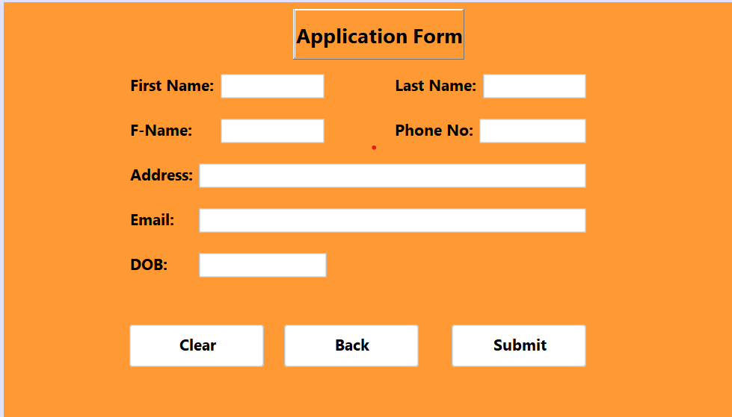

#### Use Case: Scheduling Test

|  |  |
| --- | --- |
| Use case name | Test Schedule |
| Scope | The Test Schedule use case describes the functionality of the university admission system for managing and scheduling entrance exams for prospective students. |
| Main Success Scenario | * The guest navigates to the Project University Admission system and clicks on the "Schedule Test" button. * The system presents a list of available test dates and times for the user to choose from. * The guest selects a test date and time that works for them and confirms their selection. * The system verifies that the selected test date and time are available and prompts the user to confirm their reservation. * The guest confirms the reservation and the system displays a confirmation message indicating that their test has been successfully scheduled. * The system then provides the user with any additional instructions or details they may need to know before taking the test, such as the location of the test center or what materials to bring. |
| Pre-Condition | The prospective student must have applied for admission to the university and have completed all the necessary requirements to be eligible to take the entrance exam. |
| Primary Actors | Admin, students |
| Level | Level 1: Basic Level: The admission staff member schedules the entrance exam for the prospective student.  Level 2: Intermediate Level: The system displays a list of available dates and times for the exam.  Level 3: Advanced Level: The system confirms the date and time of the exam and notifies the student via email or other means. |
| Stake Holders | Admission staff - responsible for scheduling and managing entrance exams for prospective students.  Prospective students - responsible for attending the entrance exam as per the scheduled date and time. |
| Success Guarantee | The entrance exam is scheduled for the student on a convenient date and time, and the student is notified of the exam details. |
| Exceptions | If the admission staff member encounters any technical difficulties while scheduling the exam, they can contact the university helpdesk for assistance.  If the student is unable to attend the scheduled exam, they can contact the university to reschedule for a different date and time.  If there is an error with the database or system, the system will display an error message and prompt the staff member to try again later. |
| Special Requirements | The system should allow the staff member to view the scheduled exam details and make changes if necessary.  The system should be able to generate reports on the exam scheduling and attendance for administrative purposes. |
| Technology and data variation list | Technology: The university admission system is a web-based application that requires a modern web browser and an internet connection.  Data Variation: The list of available exam dates and times may vary based on the availability of exam proctors and facilities. |
| Frequency of occurrences | This use case occurs for each eligible student who has completed all the necessary admission requirements to take the entrance exam. |
| Miscellaneous | The university admission system should have a feature to automatically reschedule an exam if a student fails to attend the scheduled exam.  The system should have an option to cancel an exam and notify the student if the exam cannot be held due to unforeseen circumstances such as natural disasters or system outages.  The system should have a mechanism to prevent overbooking of exam dates and times to ensure the smooth conduct of exams. |
| Prototyping | A prototype of the Test Schedule use case can be developed to demonstrate the following functionalities:  The ability to display a list of eligible students who have completed all the necessary admission requirements to take the entrance exam.  The ability to select a student from the list and schedule an entrance exam for them.  The ability to display a list of available exam dates and times.  The ability to confirm the exam date and time and notify the student via email or other means.  The ability to handle errors and exceptions gracefully.  The ability to generate reports on the exam scheduling and attendance for administrative purposes. |

#### Use Case: Announcement

|  |  |
| --- | --- |
| Use Case Name: | Announcement |
| Scope: | University Admission System |
| Primary Actors: | Admin, Students |
| Stakeholders and Interests: | Admission Officer: Need to inform prospective students about the admission process and deadlines. Prospective Students: Need to receive timely and accurate information about the admission process to make informed decisions. |
| Precondition: | The admission officer has access to the announcement section of the admission system. |
| Success Guarantee: | Prospective students receive timely and accurate information about the admission process and deadlines. |
| Main Success Scenario: | * The administrator navigates to the announcement section. * The administrator creates a new announcement with a title, description, and deadline. The admission officer publishes the announcement to the admission system. * The prospective guest navigate to the announcement section. * The prospective guest read the announcement and take appropriate action. |
| Extensions: | If the admission officer fails to create a new announcement, the system displays an error message and the use case ends. If the admission officer fails to publish the announcement, the system displays an error message and the use case ends. If the prospective students fail to read the announcement, the system sends a reminder to their registered email address. |
| Frequency of Occurrence: | Multiple times a year, depending on the admission cycle. |
| Technology and Data Variation List: | The admission system should support multiple languages for the announcement text. The system should be accessible from different devices such as desktops, laptops, tablets, and smartphones. The system should be able to handle a large number of concurrent users during peak admission periods. |
| Prototype: | A prototype of the Announcement use case can be developed to demonstrate the following functionalities The ability to create and publish announcements. The ability to display announcements in a user-friendly format. The ability to send email reminders to students who have not read the announcements. |
| Special Requirements: | The announcement section should be easy to navigate and accessible to all prospective students. |
| Level: | User Goal |
| Use Case Section: | Main Flow, Extensions |
| Miscellaneous: | The admission officer should be able to edit or delete announcements if necessary. The system should have a mechanism to ensure that the announcements are displayed in chronological order. The system should be able to track the number of views and clicks on each announcement for administrative purposes. |